***Introduction to Excel for Data Analysis***

**Task 1 (Excel)**

In the worksheet below, I was able to generate data for employees using the following parameters:

* Employee Id
* Employee Full Name
* Department (Communication, IT, and Sales)
* Salary ($5,000- $25,000)
* Job Type (Freelance, Contract, Part-time)



From the snapshot of worksheet 1 of my analysis above, I filtered the employees who are freelancers and whose salary is greater than or equal to $10,000. From the analysis, the Freelancers that were paid above $10,000 are three (2 from IT department and 1 from Communication department).

From the snapshot of worksheet 2 below, I was able to split the employees full name to first name and last name by using the text to column function.





From the snapshot of worksheet 3 above, I was able to filter the employee’s full name which start with "E", and then sorted the data to get the highest paid and lowest paid employees, and then ended up checking if there are any duplicates using conditional formatting.

From the analysis,

* Three employees’ names started with the letter E and was highlighted in yellow color.
* The highest paid was highlighted in green and the lowest paid was highlighted in red.
* There were no duplicates.

**Task 2**

This task was all about analyzing a sales data and providing the following information from the analysis:

* Total Revenue and Profit generated.
* Average revenue and units sold for every order.
* Total Discount given in $.
* Total Number of sales recorded.
* Highest Profit.
* Create a column called ‘Sales range’ and use formula to show ‘high sales’ and ‘low sales’.
* Average Revenue from Each Sale of "Paseo".
* Number of Sales made in "Government".
* Number of Sales made in "Midmarket".
* Number of Sales made in Government and Midmarket.
* Total Revenue generated from sales of "Montana" in Canada.
* The country segment, Month that has the highest unit sold.
* Total profit made in December.

[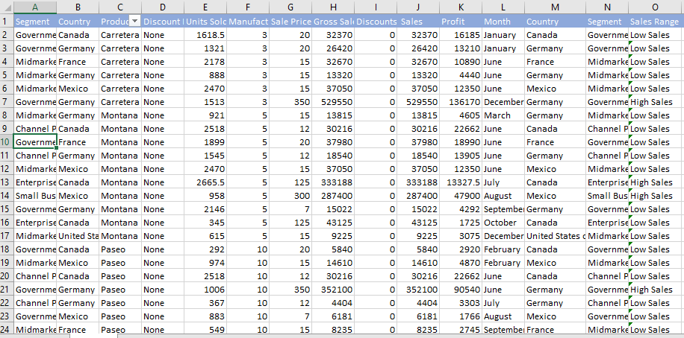](https://user-images.githubusercontent.com/64136357/256052004-f9bba6f6-9510-4270-aaba-59dc12b7b04e.PNG)

From the worksheet of the sales data above, the information need was analyzed and presented in the table below:



**IN CONCLUSION**

The information provided on excel spreadsheet was successfully analyzed and findings gathered from the analysis can be used to make data-driven decisions that can impart positively on the growth of businesses and companies. The skills applied in this analysis are as follows; Data manipulation, use of conditional formatting, use of filters, text-to-column and use of some excel formulas.